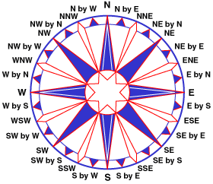
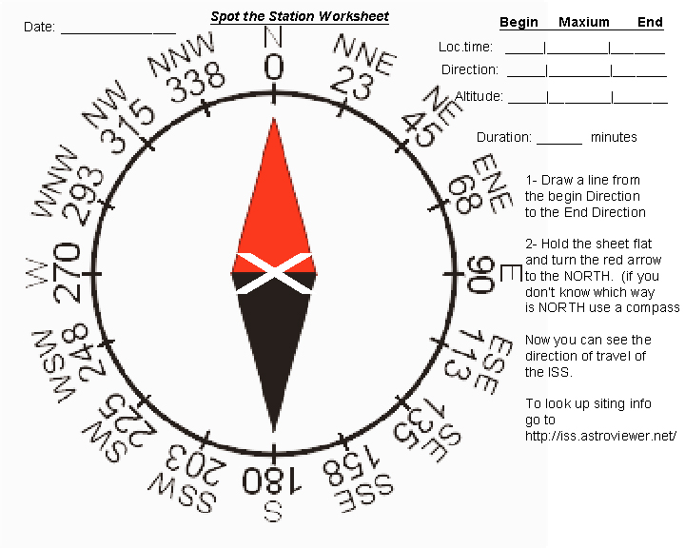
Verified by:
w.Roger Peeples

_________________________

Amateur Radio Call: KD6FBF
Observer

___________
ISS Mission 58
http://spotthestation.nasa.gov/

